Lab Assignment No: 03

NAME: Vivek Pundkar ROLLNO: 77

CLASS: C BRANCH: ENTC BATCH: 3

Problem statement:

Write equijoin, non-equijoin, self-join and outer join queries. Write queries containing single row / multiple row / correlated sub queries using operatorslike =, in, any, all, exists etc. Write DML queries containing sub queries. Study a setof query processing strategies.

1.

i) Get the information of the department id 1,2, and 3.

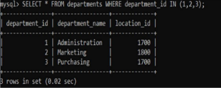

ii) Get the information of employees who work in the department id 1, 2 and 3.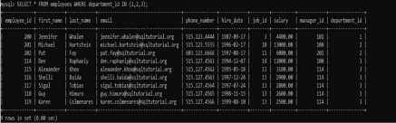

iii) Combine data from employee and department tables.

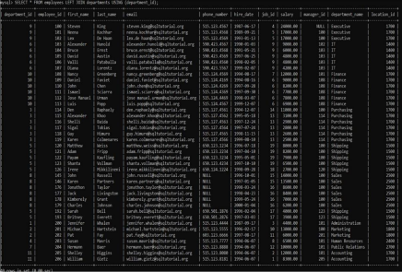

iv) Get the first name, last name, job title, and department name of employees who work in department id 1, 2, and 3 (Use employees, departments, and jobs).

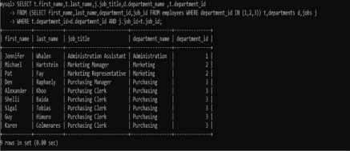2

2.

i) Query the country names of US, UK, and China (From the country code). 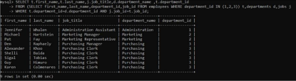

ii) Retrieves the locations located in the US, UK and China.

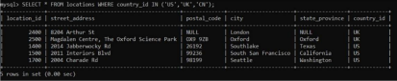

iii) Find the country that does not have any locations in the locations table. 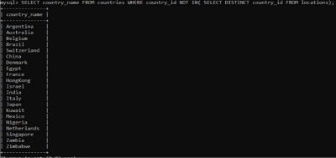

iv) Join 3 tables: regions, countries, and location.

